Food ordering site

1. Introduction

* My website is a food ordering site in which you can see verity of food. And I will include tab-pills, nav bar, forms etc.
* The purpose of my website is to make user interface easy and clean.

1. User Interface Design and Prototype
   * My prototype includes all the feature that I will make such as navbar, card, images, button etc.
   * 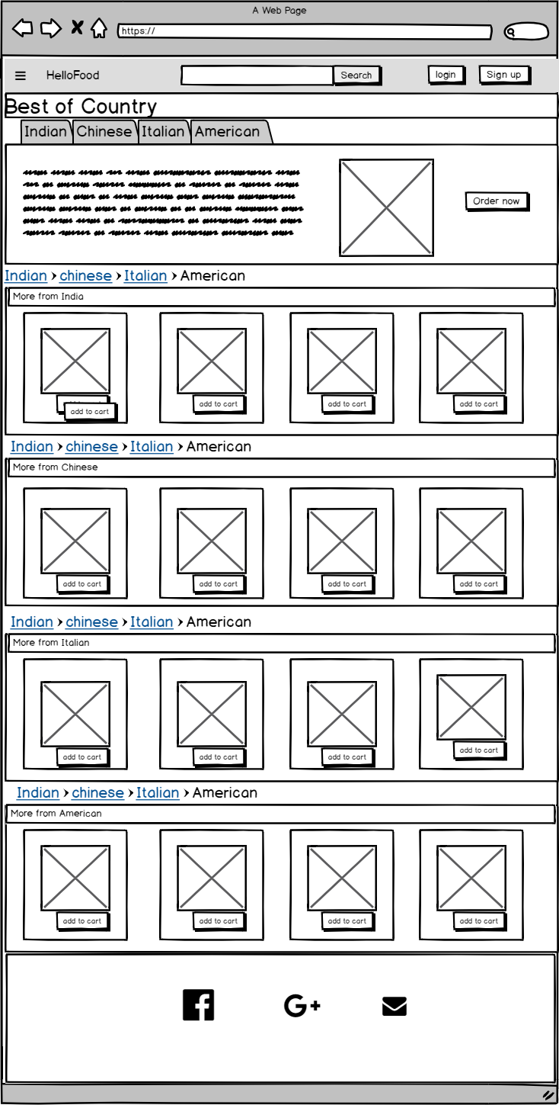
2. Navigation Structure
   * Me website includes login and sign up to sign up and there is add to cart option and for all these I use bootstrap modal. And my website is single page website in which you don’t need to go other page all thing will be done in one-page bootstrap modal class.
   * Example : when you click on login this login module open
   * 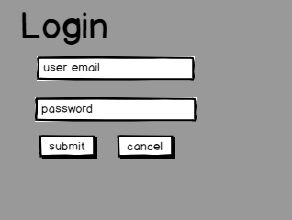
3. Reference
   * For prototype
     1. <https://balsamiq.cloud/>
   * For ui design
     1. <https://getbootstrap.com/>